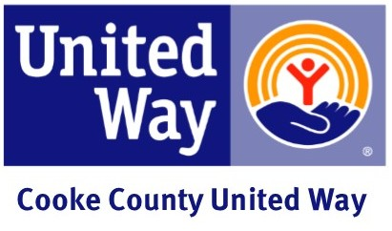

Sample Kickoff Announcement
Dear Employee,
Please mark (Date) on your calendar as the kick-off for (Company’s) annual United Way fund-raising effort. This year’s campaign will run from (Date To Date) and our Campaign Coordinator (Name), has put together a series of exciting events for us to participate in and support.
(Company Name) cares deeply about our community and the quality of life that makes the Cooke County area unique. And United Way focuses resources to provide solutions for our community’s most pressing problems.
Through our contributions, we can make sure help is there for families, co-workers and friends. United Way assures that a broad range of services are available to help local people become independent and self-sufficient. I believe that supporting United Way is a sound decision. We will have a chance to learn more about United Way during our upcoming kickoff rally.
(Company Name) is proud to support Cooke County United Way. See you all at the kickoff.
Sincerely,
(CEO/Manager)

