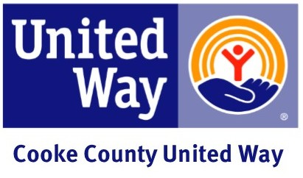

Progress Report Email
Subject: United Way Progress Report!

Congratulations team!

We’ve reached ______% of our goal.

Please turn in your pledge cards by (date), so that we can achieve our final goal of (amount).

I’m proud to be part of this exciting effort to create opportunities for a better life for all. I’d be happy to answer any questions you have about giving to United Way.

Sincerely,

(CEO and/or Coordinator)

