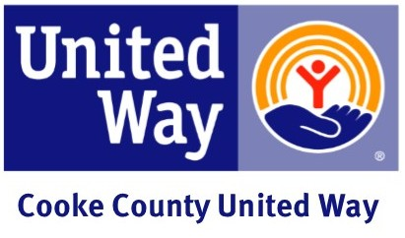

Announcement of Company Campaign Email
Subject: Campaign Dates
This year our United Way campaign begins on (date). We have many fun activities planned. United Way gives us an opportunity to fight for what we believe in. I am excited and encourage your involvement.
Below are some important dates to mark on your calendar:
(DATE) ________________ (Kickoff Event/Meeting)

(DATE) ________________ (Event/Meeting)

(DATE) ________________ (Event/Meeting)

(DATE) ________________ (Event/Meeting)

(DATE) ________________ (Pledge forms/donations due)

Bring your enthusiasm!

Sincerely,
(CEO and/or Coordinator)

