
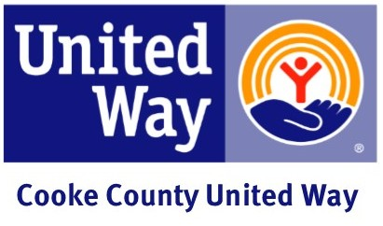

Special Event and Incentive Ideas

Running a United Way Campaign is good for Cooke County and your organization. They bring employees together to support our community and have FUN!

Include one or more special events in your United Way Campaign to help motivate and promote team spirit, increase awareness and raise money to support progress towards solutions for all. You are the real experts when it comes to special events at your business.

Food Fundraisers!
FOOD FUNDRAISERS


Why add incentives?

To encourage first-time donors to make a gift.
To encourage a pledge increase or a leadership gift.
To encourage employees to attend meetings and campaign events.
Bake Sale

Employees donate homemade items to be sold to fellow employees with the proceeds going to the campaign.

Build Your Own Sundae

Create a sundae bar with an assortment of ice creams and a wide variety of toppings. This can also serve as a thank you event.

Muffin Mondays

Bake or purchase muffins to sell to employees as they arrive on Monday mornings. Add all of your earnings to the campaign total.

Snack Shoppe

Set up an area where employees can purchase soft drinks, candy bars, chips, peanuts, etc. and add all of your earnings to your campaign total.

Hot Dog Sales

Sell hot dogs, chips, and a soft drink or water in front of the business to customers and employees.

Plate Lunch Sales

Have employees cook and sell plate lunches for $5. All proceeds go to the campaign.

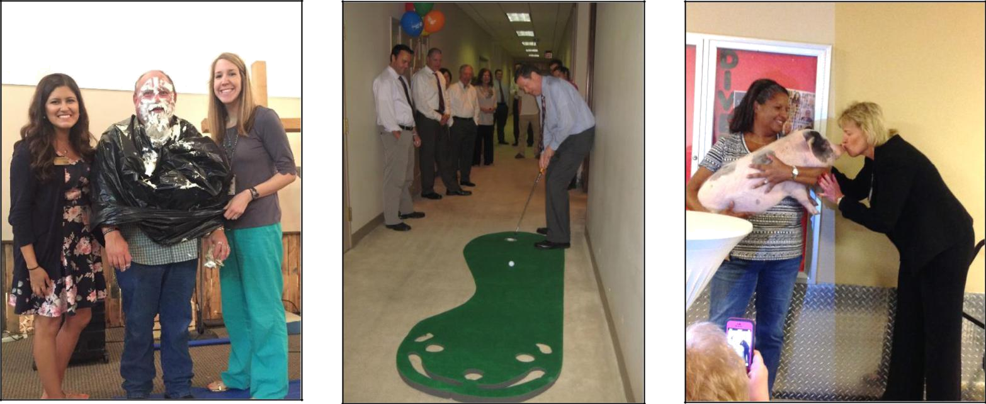

Fun & Games!

Pie Your Boss

Each supervisor or department head has a bucket with their name on it. Employees donate into the bucket of the supervisor they’d like to see get pied in the face. The individuals with the most money in their bucket gets a pie to the face.

Balloon Pop!

Put the name of a donated prize in each balloon. Allow employees to purchase a balloon and pop it to reveal their prize.

Putt-Putt Tournament

Set up a miniature golf course throughout the office. Have departments design each hole, using United Way information and materials. Give prizes to top finishers.
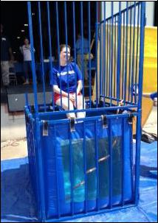

Kiss the Pig

Post pictures of executives next to a piggy bank. Have employees vote for the executive of their choice to kiss a pig by donating coins and cash. The manager with the most money puckers up!

Auction/Silent Auction

Auction off executive-parking spaces, donated merchandise or services. Try conducting the auction over your intranet site, or have a silent auction in the break room.

Dunk Your Boss

Set up a dunking booth with your “dunkable” executives. Set a price on three throws and give your employees a chance to dunk their boss!

