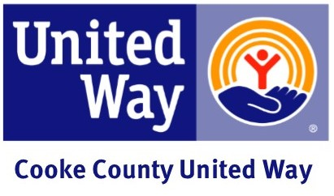

Encouragement Email
Subject: What Will You Live United Against?

(Business Name) is currently running our 2021United Way Campaign. We have been given an opportunity to band together with United Way to surround our community’s most critical problems. Whether it’s feeding starving children, providing access to healthcare for our senior citizens, or mentoring at risk students, our dollars will address our community’s most daunting crises. Change doesn’t happen alone. We need you to decide, what will you Live United against?

Here are some quick facts about what Cooke County United Way is and does:

501(C)3 nonprofit organization
Fights for the health, education, and financial stability of everyone.
Directly provides services to strengthen our community in the area of education.
Serves 24 towns and communities in Cooke County.

Sincerely,

(CEO and/or Coordinator)

