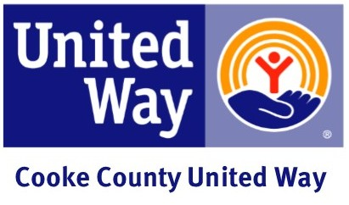

CEO Letter to Leadership Givers
Dear Executive,
Our company has always demonstrated through our contributions our belief that an investment in United Way is an investment in the community. Not only has (Company) distinguished itself as a leader in our field, but also as a leader in caring and giving to our community.
Again this year we have an opportunity to lead by example by earning one or more award such as, The Arley Daurity Award for 100 percent participation, The Presidential Award for 50 percent increase in last year’s giving, or The Community Excellence Award for giving 100 dollars per capita and having at least 80 percent participation. These awards play a big role in helping address the increasing needs of our community. They also send a clear message that you believe United Way is the best way to care for our community.
Please note that your decision to give to the campaign at any level is a personal one. Should you need additional information to make an informed decision, please do not hesitate to ask a United Way volunteer.
If you decide to participate, please complete and return the forms provided to you by (Volunteer), our company's Employee Campaign Coordinator. They will provide an additional card for you to complete for recognition purposes. Although you may choose to remain anonymous, United Way believes that publicizing leadership contributor's names sets a positive example for other donors who also might be able to give at the leadership level. Thank you in advance for your consideration, and for helping (Company Name) Live United.
Sincerely,
(CEO / Manager)

